9th SMRIKVA BOWL
3rd “Little Mo”/SMRIKVA BOWL
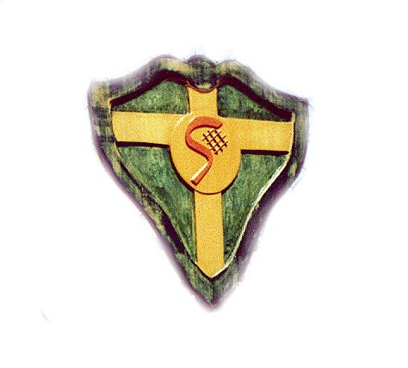
SMRIKVE
1924

PULA, CROATIA 30 JUNE - 4 JULY 2004

9th Smrikva Bowl – tennis tournament for boys and girls under 10 - gathered around 80 boys and girls from many European countries. It was another successful annual.

The proof of the Smrikva Bowl importance is given by the names of the winners:
- Vilim Visak (Cro) Natali Zuliani (Cro) 1996
- Željko Perić (Cro) Ivana Lisjak (Cro) 1997
- Filip Kovačić (Cro) Mateja Horvat (Cro) 1998
- Borko Mudronja (Cro) Astrid Besser (I) 1999
- Adelchi Virgili (I) Tereza Mrdeža (Cro) 2000
- Marin Draganja (Cro) Petra Martić (Cro) 2001
- Javier Marti Herraiz (E) Martina Caregaro (I) 2002
- Dominic Thiem (A) Jennifer Ren (UK) 2003

Ivan Levar won boys finals and Saska Gavrilovska the girls finals. The winners won mountain bikes and runner up the Babolat rackets.

On 4th of July 2004, the Smrikva Bowl finalist – Ivan Levar (Croatia), Miki Jankovic (Serbia and Montenegro), Saska Gavrilovska (Serbia and Montenegro), Ecaterina Opriou (Romania) - played the 3rd «Little Mo» / Smrikva Bowl in Smrikve Tennis Club in Pula, Croatia. Mitchell Polnet, Ryan Andrada, Blair Shankle and Anna Mamalat have been selected by MCB foundation to represent the United States.

European team won 6:2 the 3rd “Little Mo”/Smrikva Bowl.

The Smrikve Tennis Club and the Maureen Connolly Brinker Tennis Foundation have created «Little Mo» / Smrikva Bowl, the first-ever international competition between the United States and Europe for boys and girls 10 & under.

9th SMRIKVA BOWL RESULTS

Boys:

Finals: Ivan Levar (Cro) - Miki Jankovic (SiCG) (6 : 2 6 : 3);

Semifinals: Ivan Levar (Cro) – Nerman Fatic (BiH) (9 : 2); Miki Jankovic (SiCG) – Filip Veger (Cro) (9 : 1);

Quarterfinals: Ivan Levar (Cro) - Dere Laslo (SiCG) (9 : 3); Nerman Fatic (BiH) – Luka Ilic (SiCG) (9 : 3); Miki Jankovic (SiCG) – Branko Atanackov (SiCG) (9 : 3); Filip Veger (Cro) - Filippo Saloli (I) (9 : 3).

Girls;

Finals: Saska Gavrilovska (SiCG) - Ecaterina Opriou (Rom) (6 : 3 6 : 1);

Semifinals: Saska Gavrilovska (SiCG) – Barbara Krvavac (Cro) (9 : 8); Ecaterina Opriou (Rom) – Anja Cosovic (Cro) (9 : 4);

Quarterfinals: Saska Gavrilovska (SiCG) – Christine Kandler (A) (9 : 8); Barbara Krvavac (Cro) – Francesca Palmigiano (I) (9 : 3); Ecaterina Opriou (Rom) – Anita Husaric (BiH) (9 : 3); Anja Cosovic (Cro) – Martina Parmigiani (I) (9 : 8).

3rd “Little Mo”/SMRIKVA BOWL RESULTS

Europe USA

Boys:
Ivan Levar (Cro) – Ryan Andrada (USA) (6:1 6:1)
Miki Jankovic (SiCG) – Mitchell Polnet (USA) (7:5 6:1)

Ivan Levar (Cro) – Mitchell Polnet (USA) (6:3 6:3)
Miki Jankovic (SiCG) – Ryan Andrada (USA) (6:2 6:3)

Girls:
Saska Gavrilovska (SiCG) – Anna Mamalat (USA) (6:3 6:1)
Ecaterina Opriu (Rom) – Blair Shankle (USA) (0:6 1:6)

Saska Gavrilovska (SiCG) – Blair Shankle (USA) (2:6 3:6)
Ecaterina Opriu (Rom) – Anna Mamalat (USA) (6:1 6:4)

FINAL SCORE 6 - 2

